**Nikita Mhase**

**WORK LIFE BALANCE AND ENGAGEMENT ANALYSIS**

**Dashboard 2 Report:**

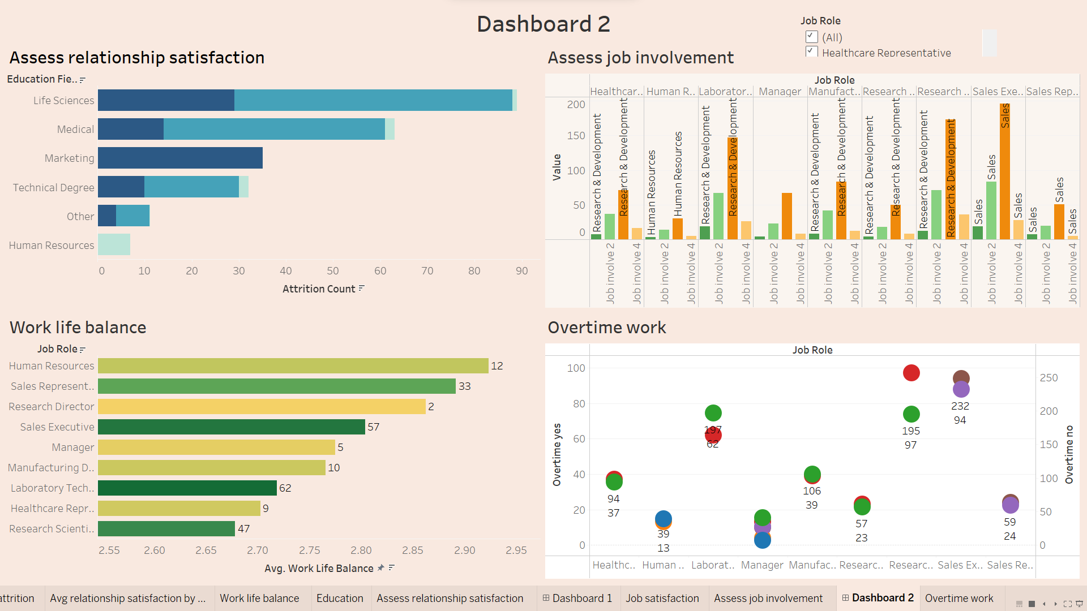

**Average Work-Life Balance Rating:** By examining the average work-life balance rating displayed on the dashboard. Identify any trends or discrepancies in work-life balance across different departments.

Results: The different departments available in work life balance are as follows

1. Sales
2. Research and Development
3. Human Resources

Research and development has the highest attrition percentage count followed by sales and then human resources. Job satisfaction attrition count with respect to work life balance is high in laboratory technician which comes from the research and development department. Even the job satisfaction rating is 3 or 1 the research and development has the highest attrition count. Then the sales part is on second number and in them sales executive is at highest.

**Assess Job Involvement:**  
   Analyze the average job involvement metric to understand how engaged employees are in their work. Look for any patterns or correlations between job involvement and other factors such as department or job role.

According to job role, and job involvement rating the people rated 3 are more in numbers highest in job role sales executive with number 196 followed by job role research scientist with number 173 and lowest in human resources.

After this people rated 2 are more in numbers .The least people have rated 1 for job involvement. So this means people are bitterly involved in their job. The least people involved are from the research and development department.

**Relationship Satisfaction:**  
   - Review the average relationship satisfaction score to gauge the quality of workplace relationships. Identify any departments or teams where relationship satisfaction may be lower and investigate potential causes.

So here engaged employees can be seen through Average relationship satisfaction (with their work).Lets look on pattern with job role and Average relationship satisfaction. So average relationship satisfaction is 2.7 of every job role approximately. So the most satisfied job role is human resources (2.96) followed by manager (2.81). The attrition count is 12 of human resources and that of manager is 5. The **lowest avg relationship count is 2.6 of sales representative** with attrition count 33 and the highest is 62 with 2.68 as avg satisfaction.

Lowest is sales and when cross checked with education we can see the marketing educational field is one where all the sales department person works and has highest attrition count of 35. So educational field may be one of the potential causes.

**Examine Overtime Work Distribution:**  
    Explore the distribution of employees who work overtime compared to those who don't. Determine if there are any departments or roles where overtime work is particularly common and assess its impact on work-life balance and job satisfaction.

So from this SCATTER plot we can see that Research and development is the department where overtime is done on a large scale. To compare the very large difference is in the number of sales department where 232 are not doing overtime and 94 are doing overtime. Human resources have overtime work of 5 people and no overtime of 7 people.

So we can conclude that since a large difference in number of overtime yes/ no is seen in sales and research development dept. therefore the percentage of attrition count is also high in them. Which is affecting its average relationship satisfaction and work life balance count of sales being the lowest.

So we can focus on overtime part as it can be one of the important cause of attrition count.

**Identify Areas for Improvement:**  
   Based on the analysis of work-life balance, job involvement, relationship satisfaction, and overtime work distribution, identify areas for improvement. Consider implementing policies or initiatives to promote better work-life balance and employee engagement.

Areas according to the report may be

1. Educational field need to be focused on. Particularly of sales and research development and that too of life sciences, medical and marketing. Because may their expectation of work they expected may not be fulfilled leading them to the attrition count.
2. Focus on overtime part as it can be one of the important cause of attrition count. Some of the employees may feel inferior, which can lead to their low level of job and environment satisfaction eventually leading to the attrition count.
3. In overall if we need to promote better work life balance and employee engagement, we need to ensure that the people do on our onboarding are of the related field, their rating of satisfaction and work life is high. If low then do immediate meetings so none of the employee should feel inferior. And to see that balance work is given to all and none of the employee needs to do overtime unnecessary.